**git init: to initialize repository**

C:\Users\spali\Desktop\Git>git init

Initialized empty Git repository in C:/Users/spali/Desktop/Git/.git/

**git status: to check if there is any uncommitted files**

C:\Users\spali\Desktop\Git>git status

On branch master

No commits yet

Untracked files:

(use "git add <file>..." to include in what will be committed)

Git Commands.docx

~$t Commands.docx

nothing added to commit but untracked files present (use "git add" to track)

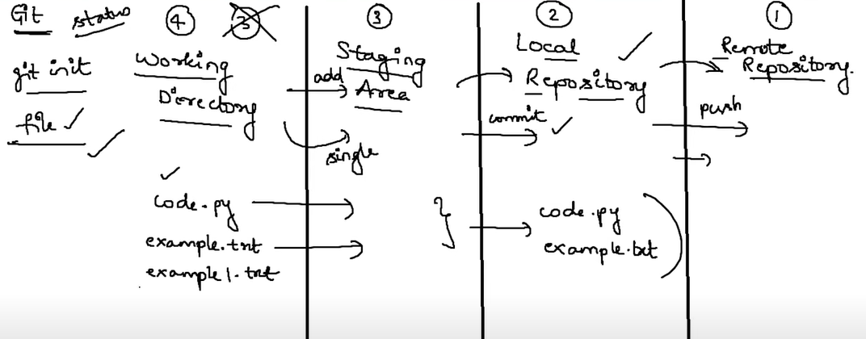

Working Directory to staging area we can send single or multiple files.

Staging Area to Local Repository using commit, or Local Repository to Remote Repository using push, we have to send all files. We cannot cherry pick.

git add: adds files to Staging Area

C:\Users\spali\Desktop\Git>git add "Git Commands.docx"

C:\Users\spali\Desktop\Git>git status

On branch master

No commits yet

Changes to be committed:

(use "git rm --cached <file>..." to unstage)

new file: Git Commands.docx

Untracked files:

(use "git add <file>..." to include in what will be committed)

Example..txt

To add identity we need two commands

**git config -- global user,name “Suman Palisetty”**

**git config – global user.email “spalisetty@gmail.com”**

C:\Users\spali\Desktop\Git>git commit -m "Git Commands file is committing now"

Author identity unknown

*** Please tell me who you are.

Run

git config --global user.email "you@example.com"

git config --global user.name "Your Name"

to set your account's default identity.

Omit --global to set the identity only in this repository.

fatal: unable to auto-detect email address (got 'spali@SumanCloeh.(none)')

C:\Users\spali\Desktop\Git>git config --global user.name "Suman Palisetty"

C:\Users\spali\Desktop\Git>git config --global user.email " [spalisetty@gmail.com](mailto:spalisetty@gmail.com)"

**git commit -m “sample message”: committing from staging server to Local Repository”**

C:\Users\spali\Desktop\Git>git commit -m "adding Git Commands.docx file to Local Repository"

[master (root-commit) c26c718] adding Git Commands.docx file to Local Repository

1 file changed, 0 insertions(+), 0 deletions(-)

create mode 100644 Git Commands.docx

**git remote add origin: to connect the remote repository to the local repository**

C:\Users\spali\Desktop\Git>git remote add origin <https://github.com/SumanCloehGH/Bebe.git>

**git branch: To list out all branches**

C:\Users\spali\Desktop\Git>git branch

* master

git branch: Checkout is used to jump between branches. -b is used to create a new branch and checkout into that branch.

C:\Users\spali\Desktop\Git>git checkout -b copy1

Switched to a new branch 'copy1'

C:\Users\spali\Desktop\Git>git branch

* copy1

Master

**C:\Users\spali\Desktop\Git>git branch feature1 It will create a new branch feature1**

**C:\Users\spali\Desktop\Git>git checkout feature1 It will checkout to feature1**

**C:\Users\spali\Desktop\Git>git checkout -b feature1 it will create and checkout**

**We create Pull Request once our code is committed in a branch and we pushed it to the origin. Now in order to create Pull Request, I click on Compare and Pull. My Team lead looking at the code I created, without conflicts, he merges into the Master.**